**Name :**

**Hafsa Waseem**

**Roll no:**

**SU92-BSSEM-S24-014**

**Subject :**

**DSA (Lab)**

**Section :**

**3A**

**Submitted to:**

**Sir Rasikh**

**Task no 13:**

**DFS and BFS**

**1. Insert and Traverse for DFS in tree**

**2. Insert and Traverse for DFS in graph**

**3. Insert and Traverse for BFS in tree**

**4. Insert and Traverse for BFS in graph**

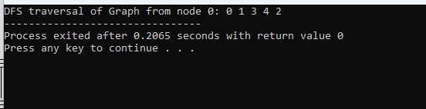

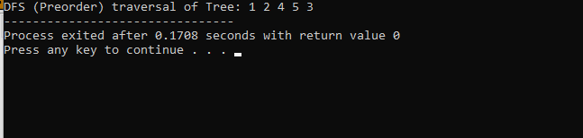

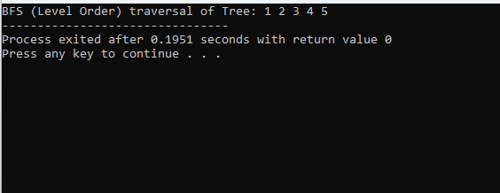

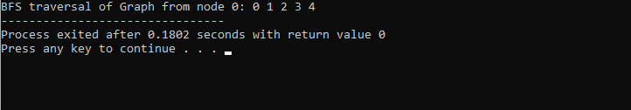

**Explain :**

This code shows how to use DFS and BFS to add and go through trees and graphs. In trees, DFS goes deep from root to left and right, while BFS uses a queue to go level by level. In graphs, DFS visits one path deeply using recursion, and BFS uses a queue to visit all nearby nodes first. We use arrays or lists to store links between nodes. Both methods help explore data in different ways.